2-2 Assignment: Applying a Pareto Chart

DAT-475

Ashley Littles

Southern New Hampshire University

Pareto Chart

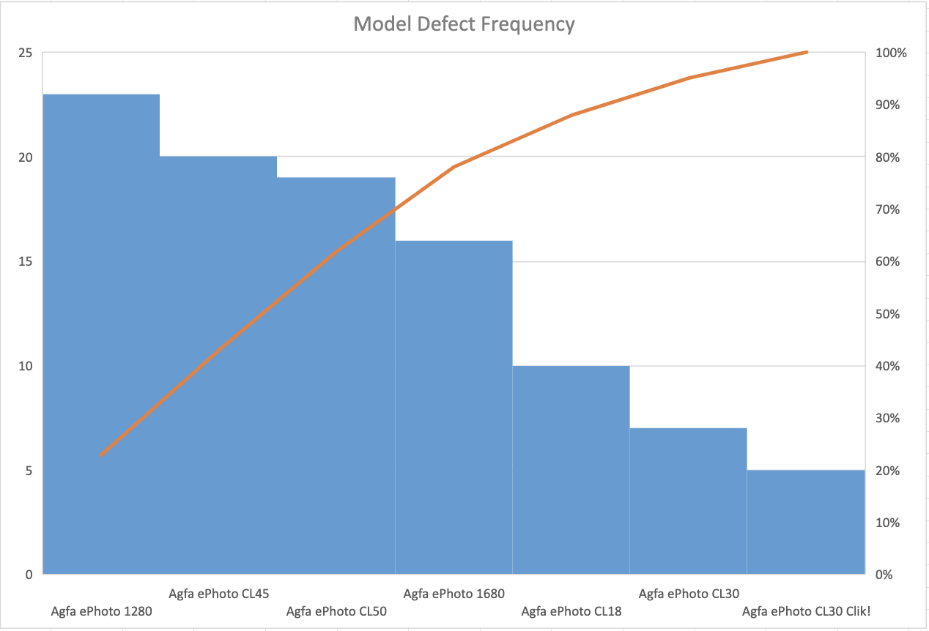 I have been assigned to create a Pareto chart to aid in finding a solution for the Afga company as to why they are getting warranty claims for their camera models. This chart shows the camera model and defect frequency along with the percentage of the defect. The Pareto chart displays the results of the data as expected. Looking at the Pareto chart we can see that the Agfa ePhoto models 1280, CL45, and CL50 are a part of the top three models with the most defects. With this data set, we do not have any significant outliers that would alter the results of the chart. We have a steady curve displayed on the chart.

After analyzing the Pareto chart, we can understand which camera models have the most impact on defect frequency. With this information Afga can take a deeper look into these models to determine why this is occurring. Ultimately, we didn’t find a specific cause of the defects so the company will have to go through testing to determine the root cause. So, our results did not solve the problem. As stated before, the additional information needed to solve the problem is what exactly is causing the Agfa ePhoto models 1280, CL45, and CL50 to produce the most defects.

References

Microsoft (n.d.) *“Create a Pareto chart”* <https://support.microsoft.com/en-us/office/create-a-pareto-chart-a1512496-6dba-4743-9ab1-df5012972856>

Excel Easy (n.d.) *“Pareto Chart”* <https://www.excel-easy.com/examples/pareto-chart.html>